No. of Pages | 5
No. of Questions | 8
Department of Computer Science and Engineering
FINAL EXAMINATION SUMMER 2012
CSE320/EEE361: Data Communications
Total Marks: 90 Time Allowed: 3 Hours

- Answer Any Six (6) questions out of Eight (8) questions.
- Figure in bracket [] next to each question indicates marks for that question.

Question No. 1

  - In communication process, protocols place a huge role, why? And who controls these protocols? [3 marks]
  - Why were the layers application, presentation and session combined to one layer in the TCP/IP model? [2 marks]
  - Differentiate between IMAP and POPv3. [3 marks]
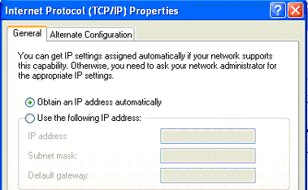
Figure No. 1

  - In above figure no. 1, the option “Obtain an IP address automatically” is highlighted. What does it imply? What protocol will it be running, explain. [4 marks]
  - To access a device we can use the telnet. But it is recommended to use telnet with SSH, why? [3 marks]

Question No. 2

- Why does a PC connected to a network while sending data require port numbers? It already has an IP address and a MAC address. [3 marks]
- UDP has no sequence number and acknowledgement number in its header but TCP does, why? [3 marks]
- Host A sends data using TCP to host B; it has negotiated a window size of 2500 bytes. It creates segments of 700 bytes each. The sequence number of the first segment is 101. How many segments can host A send? What are the sequence numbers for each of the segment? [4 marks]
- Changing the window size helps control, what? [2 marks]
- What is the purpose of SYN and FIN code bit in a TCP segment? When are they used? [3 marks]

Question No. 3

Host IP address/Subnet mask : 117.23.145.19/17
Network address
Broadcast address
First usable host IP address
Last usable host IP address
Number of usable IP addresses

- Complete the above table in your script. (Please show calculations.) [6 marks]
- Differentiate between Limited Broadcast and Directed Broadcast. [3 marks]
- What is Ping? How does it help to troubleshoot network problems? [3 marks]
- Public IP addresses are limited and expensive. So in most cases, multiple private addresses are used against one public address to access the internet. What makes it possible? Name the translation process and explain it briefly. [3 marks]

Question No. 4

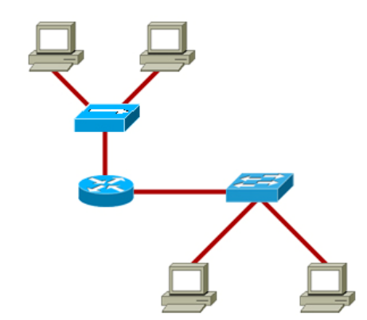
Figure No. 2
Host A

- What happens when Host A shown in figure no. 2 sends a broadcast packet? What role does the router play in sending broadcast packets? [2 marks]
Gateway of last resort is 192.168.1.2 to network 0.0.0.0

C 192.168.2.0/24 is directly connected, serial 0/0
C 192.168.1.0/24 is directly connected, FastEthernet0/0
S 196.21.21.0/25 [1/0] via 192.168.2.2
S 200.32.22.0/24 [1/0] via 192.168.2.2
S* 0.0.0.0/0 [1/0] via 192.168.1.2

Figure No. 3

- Referring to the routing table of router R1 shown in figure no.3 above, we can say R1 is not running any routing protocols, true or false? Explain your answer. [4 marks]
- What is so special about the S* route present in the routing table shown in the above figure no.3? What happens if there is no S* route? [3 marks]
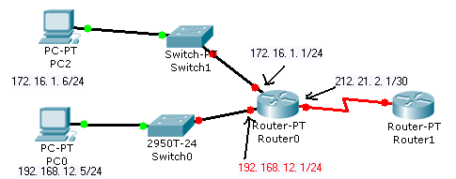
Figure No. 4

- In the above figure no. 4, you are looking at the IP configuration of PC2. There is no default gateway. What will happen if PC2 sends a packet to PC0? What will be the default gateway of PC2? [4 marks]
- IPv6 is better than IPv4, how? [2 marks]

Question No. 5

- Name the three exceptional scenarios, where bit stuffing is not done? [2.5 marks]
- What is piggybacking? Which two frames of HDLC contain the acknowledgement number? Why? [4 marks]
- In the figure No. 5 below, briefly explain what is happening? If the problem of receiver is solved, what values should be in place of “?” marks in the last two frames? [5 marks]

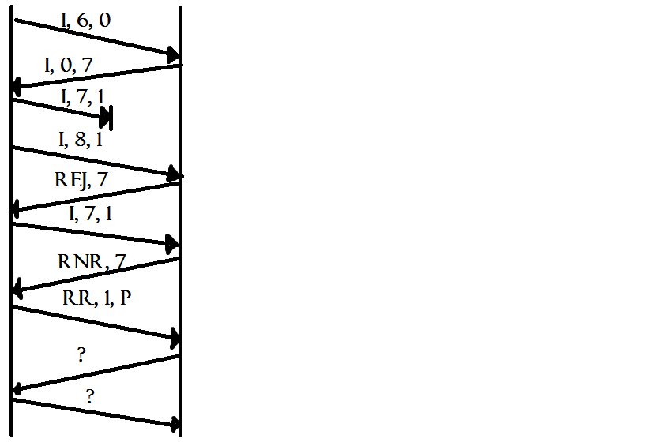
Sender
Receiver
Figure No. 5

- What is the use of unnumbered frames in HDLC? Draw the structure of an unnumbered frame along with its control field details. [3.5 marks]

Question No. 6

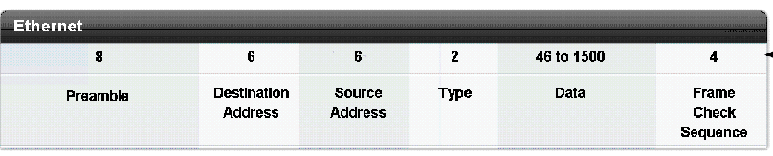
Figure no. 6

- The figure no. 6 shown above represents an Ethernet frame, what is the purpose of the frame check sequence and what kind of method is being used here? [4 marks]

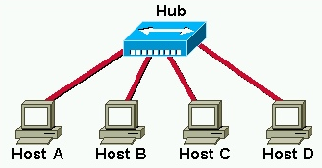
Figure no. 7

- In the figure no. 7 above Host B is sending an Ethernet frame to Host D, when Host B is nearly 50% complete, at that moment Host C also wishes to send a frame to Host D. What must Host C do? They both follow CSMA/CD. [3 marks]
- The hub connecting the hosts in the above figure no. 6 is replaced by a switch and then Host A sends a frame to Host C. what will happen next? [4 marks]
- What is the difference between 100BASEFX and 10BASET? [4 marks]

Question No. 7

- Encode the following data stream: 010110001 using Differential Manchester, NRZ-I and MLT-3 encoding methods. (Separate sheet attached) [4.5 marks]
- Compare MLT-3 and Bi-Polar AMI. [2 marks]
- Why are long streams of 0s a problem? Name the method/s available to avoid the long streams of 0s, state the processes involved in one of the method briefly? [3.5 marks]
- The receiver’s bit intervals must correspond exactly to the senders bit intervals. Why? [2 marks]
- The figure no. 8 below represents the Manchester encoding of a data stream. What is the data stream? Using Manchester is not always recommended, why? [3 marks]
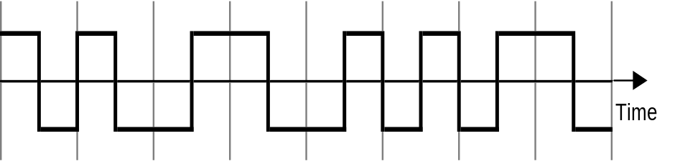

Figure no. 8

Question No. 8

- Which cable is preferable when there is chance of a lot of electromagnetic interference and why? [3 marks]

- Name and draw the light propagation modes that are used in Single Mode and Multimode Fiber Optic cables. Which propagation is better and why? [4 marks]
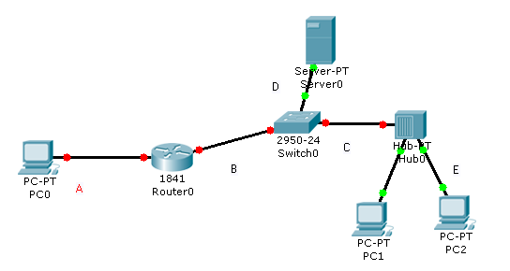
Figure No. 9

- In the above Figure No. 9, state the type of cables that will be required for each of the connection. What is the basic difference between a Straight-Through cable and a Cross-Over cable? [4 marks]
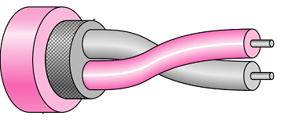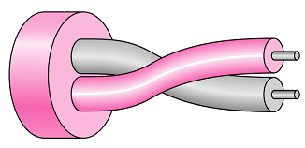
Figure No. 10a
Figure No. 10b

- What do the above two figures (figures 10a and 10b) represent? Compare the cables. Why are the wires twisted? [4 marks]

THE END

